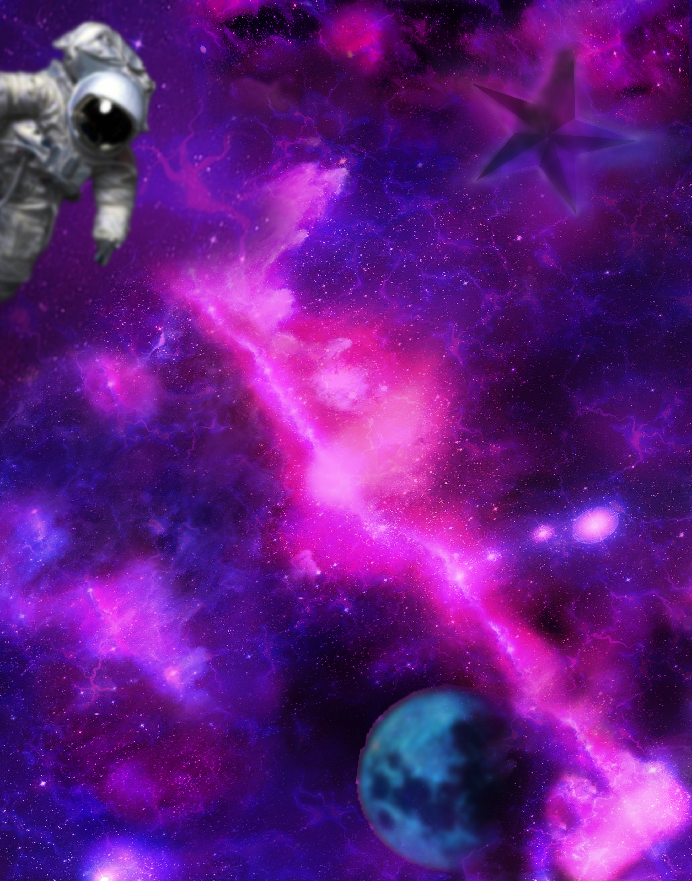

**THE ART**

**IN OUR WORLDS**

**NasArt**

Table of content

The Challenge

NASA is moving its data to the cloud, and Machine Learning/Artificial Intelligence (ML/AI) can offer an innovative means to analyze and use this massive archive of free and open data. Your challenge is to create an application using ML/AI techniques that allows users to input short text phrases, matches that input to NASA science data or imagery, and displays the results for the user in a creative and artistic manner.

Solution Summery

**High-level summary:**

The solution that we developed to Art in Our Worlds challenge is a web site that allows users to input short phrases (text or voice) and matches that input to NASA science data and imagery then displays the output in the following formats:

* Documents.
* Images.
* 3D images which can be accessed by virtual reality headsets.
* Images manipulated in an artistic manner.
* Funny filters with the output images.
* Videos.
* Images generated from text.

And the user can share all this data with others.

**Technical approaches:**

We developed a website to allow the user to access NASA’s data using the following algorithms and Artificial intelligence models:

* Speech recognition model for the search by voice feature using deep speech library.
* Document-to-document similarity. // lesa na2s
* Text to image using stable diffusion.
* text to speech using google API.
* language detection and translation using google API.
* Turning 2D images to 3D models using cube map functions.

**Project outcomes:**

The project provided great, creative, and interesting interface that helps both scientists, researchers, and public users to assess NASA’s data.

**Project Importance:**

The project made all this useful data accessible to the general public and all types of audience and the ability of sharing makes it easier to spread knowledge among the society.

**Detailed Project Description**

Project description in detail

What exactly does it do?

How does it work?

What benefits does it have?

What do you hope to achieve?

What tools, coding languages, hardware, or software did you use to develop your project

**Space Agency Data**

# **DATA Source**

# We used in our website data from” THE NASA API Portal” where NASA data, including imagery, is accessible to application developers. We used 2 APIs: Astronomy of The Day (AOTD) API, and NASA Image and Video Library API used to access the NASA Image and Video Library site at [images.nasa.gov](https://images.nasa.gov/#/).

**Data usage techniques**

**Hackathon journey**

**References**

Speech to text:

Deep speech Deep speech is made up of two pre-trained models that we have to download. It is made up of the Acoustic model and the Language model.